CASTA MEMBERSHIP APPLICATION
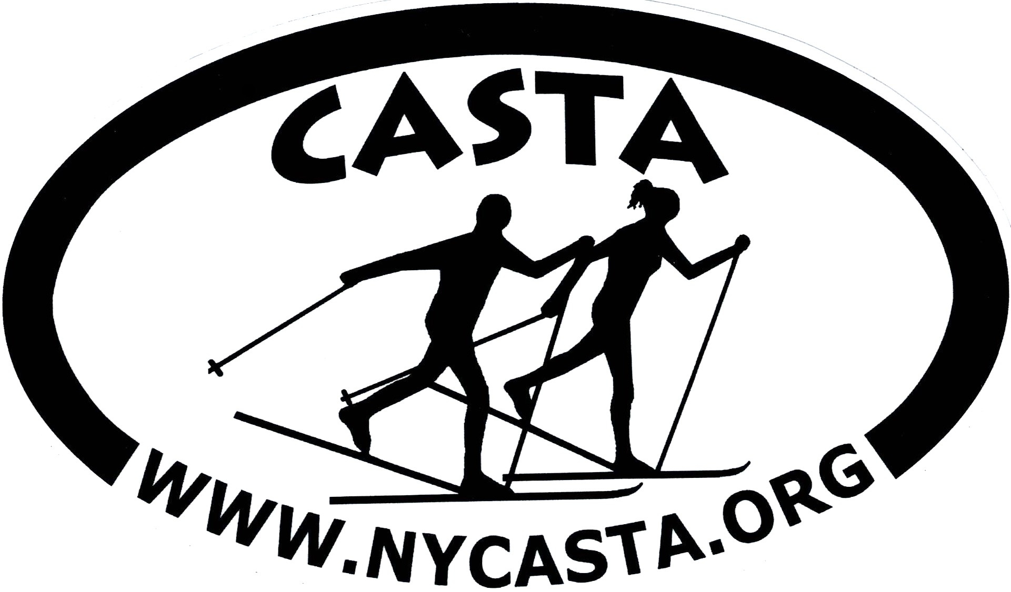

2026-27 Season (Oct 1st - Sept 30th)
(please clearly print all information)

Name_____________________________________________________________
Address______________________________________________________________________ City_______________________________________State_________ Zip Code___________ Cell Phone_____________________________ Home phone__________________________
E-Mail address: ______________________________________________________________ New Members: How did you hear about CASTA? ___________________________________
Membership: $30/yr | Please mark: renewal; new member
Skiing Ability: ___ Beginner ___ Intermediate ___ Expert
Member's age during ski season (Nov-Apr 2027) ______________. This is used for senior discounts at our skiing venues. Picture ID may be required by ski area vendors. Please do not put date of birth.
Emergency Contact: Name____________________________ Phone # _________________________
Waiver: I understand that cross-country skiing is an outdoor activity that requires a level of physical fitness that matches the difficulty of skiing that I will be doing. I am responsible for maintaining a level of fitness required for my own personal safety. Participation in club sponsored activities is at my discretion and I agree to hold the club and officers harmless for my personal safety and property.

Signature: Date:

Payment type: ____ Venmo/Zelle e-payment (located at: CASTA_Albany or rowager1948@gmail.com)
____ check made out to “CASTA”

Bring application & payment to a club meeting - or - scan/email Application - or - mail Application & check to:

CASTA
c/o Ron Wager, Treasurer
4199 NY150 West Sand Lake, NY 12196
rowager1948@gmail.com 518-275-8675

